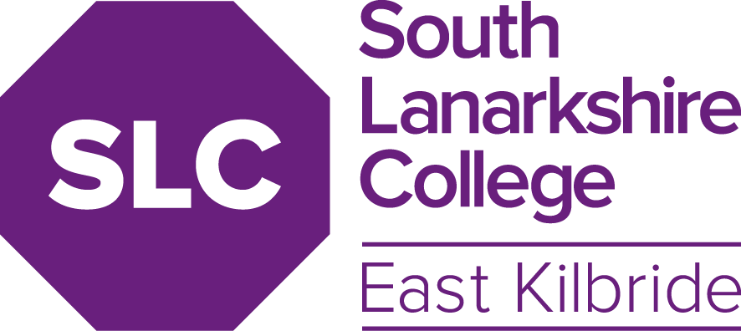
Publishable Version
HR COMMITTEE
DATE: | February 2022
TITLE OF REPORT: | 14-22 Absence Management
AUTHOR AND CONTACT DETAILS | Gary McIntosh, Head of Human Resources gary.mcintosh@slc.ac.uk
PURPOSE: | Provide the HR Committee with a quarterly update on Absence Management.
KEY  RECOMMENDATIONS/ DECISIONS: | The Board is asked to:  1. Note the updates relating to staff absence.
RISK | 1. Business, employee and student impact of long term and/or frequent absence.
RELEVANT STRATEGIC  AIM: | Successful Students – skilled & knowledgeable staff  Highest Quality Education & Support – valued & enthusiastic staff; high-quality support services; productive partnerships  Sustainable Behaviours – effective leadership and management; excellent governance; continuing professional learning and development; appropriate risk management
SUMMARY OF REPORT: | The report will provide insight into each of the following areas: • 5-year Rolling Absence Trend  - Departmental Absence Data.  - This report is not for publishing

